Coupon Redemption

Use cases:

1. **Create Coupon.**

To create coupons which user can redeem on the checkout page and get fixed percentage discount on the cart total:

* 1. **In backoffice explorer goto Marketing>Coupon Management>Coupons.**

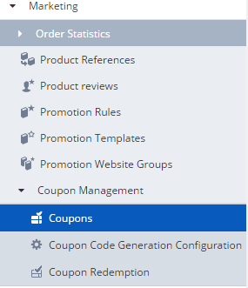

**2.2 Create Single code coupon and don’t forget to change Active status to “True”**

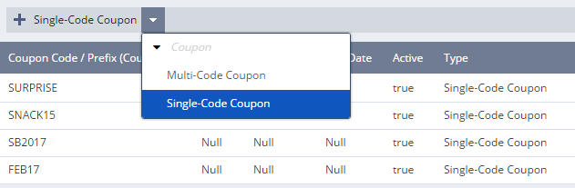

**2. Create a new Promotion Rule**

2.1 For the time being we create our promotion rule by copying one of the promotion templates available under Marketing.

2.2 Click on the highlighted button and a new rule will be created by copying the chosen template.

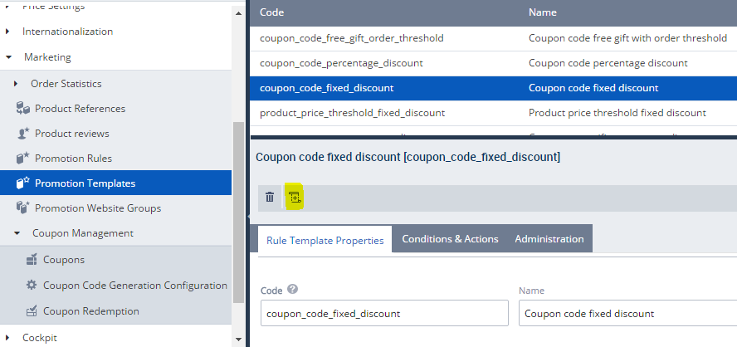

2.3 Now the new rule is visible under Promotion Rule.

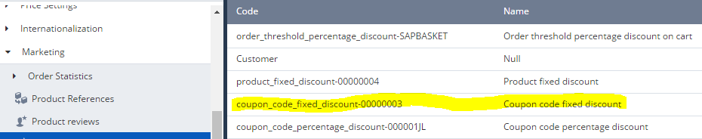

2.4 Click on the promotion rule and you will get options like Properties, Conditions and Actions, etc.

2.5 In condition give the coupon code you created in the first step and action add the fixed amount user gets on redemption.

2.6 After this publish the rule.

**3. Coupon Redemption**

3.1 Marketing>Coupon Management>Coupon Redemption

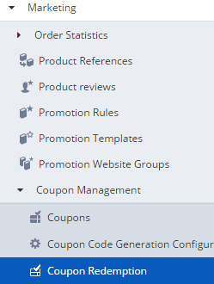

3.2 Create new coupon redemption, a dialog will appear now give coupon and coupon code

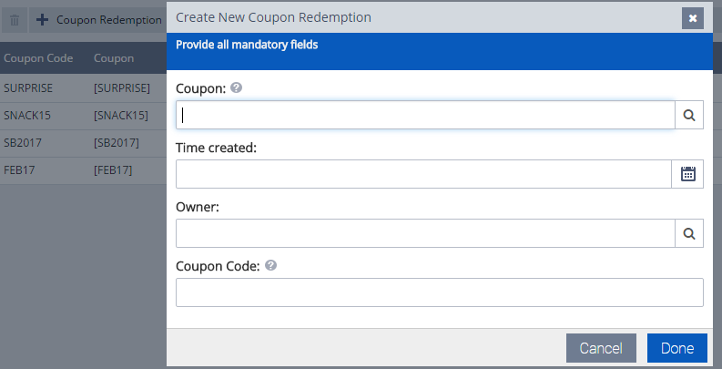

Now you can apply and redeem the coupon on checkout page.